GIBBS PHENOMENON – Square Wave

clear all;

close all;

clc;

% Time period and other variables

time_period = 2; % square wave

step_size_t = 0.0001;

t = 0:step_size_t:time_period;

tt = length(t);

omega_o = 2 * pi / time_period; % Fundamental angular frequency

% Number of Fourier coefficients

no_of_fourier_coeff = 50;

kk = -no_of_fourier_coeff:1:no_of_fourier_coeff;

% Initialize v_t for square wave signal

v_t = zeros(1, tt);

for ii = 1:tt

if (t(ii) <= 1) % High part of the square wave for 0 <= t <= 1

v_t(ii) = 1;

else % Low part of the square wave for 1 < t <= 2

v_t(ii) = -1;

end

end

% Plot the square wave

subplot(4,2,[1,2]), plot(t, v_t);

xlabel("time(t)");

ylabel("v(t)");

title('Square Wave');

% Fourier coefficient array initialization

a_k = zeros(1, 2 * no_of_fourier_coeff + 1); % For storing Fourier coefficients

% Calculate Fourier coefficients

for ii = 1:1:(2 * no_of_fourier_coeff + 1)

k = kk(ii); % Fourier series index

temp1 = v_t .* exp(-1i * k * omega_o * t); % v(t) * exp(-j * k * omega_o * t)

% Integrate over the period using trapezoidal rule

int_ans = my_int_func(temp1, step_size_t);

% Calculate Fourier coefficient

a_k(ii) = (1 / time_period) * int_ans;

end

% Plot Fourier coefficients

subplot(4,2,[3,4]), stem(kk, abs(a_k));

xlabel('k');

ylabel('|a_k|');

title('Magnitude of Fourier Coefficients');

% Initialize harmonics

harmonics = zeros(1, tt);

% Reconstruct signal from harmonics

mid_term_of_fs = no_of_fourier_coeff + 1;

for ii = 1:no_of_fourier_coeff % Fixed range for ii

if ii == 1

harmonics = harmonics + a_k(mid_term_of_fs) * exp(1i * 0 * omega_o * t);

else

harmonics = harmonics + a_k(mid_term_of_fs - ii + 1) * exp(1i * (ii-1) * omega_o * t) + ...

a_k(mid_term_of_fs + ii - 1) * exp(-1i * (ii-1) * omega_o * t);

end

end

% Plot the harmonics

subplot(4,2,[5,6]), plot(t, real(harmonics));

title('Harmonics of the Reconstructed Signal');

% Plot the reconstructed signal vs original signal

reconstructed_signal = real(harmonics);

subplot(4,2,[7,8]), plot(t, reconstructed_signal, 'b', t, v_t, '--r');

title('Reconstructed Signal vs Original Signal (with Gibbs Phenomenon)');

% Custom integration function

function [int_ans] = my_int_func(Data, step_size_t)

int_ans = (step_size_t / 2) * (Data(1) + Data(end) + 2 * sum(Data(2:end-1)));

end

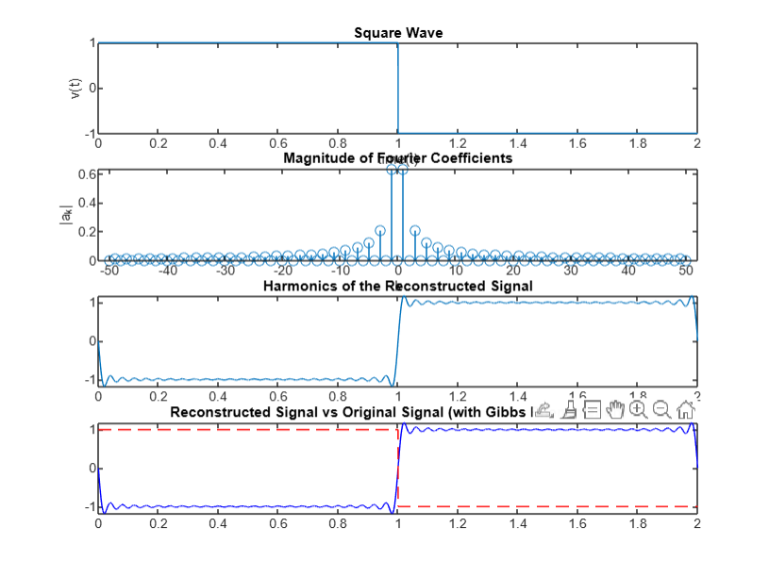

GIBBS PHENOMENON – Triangular Wave

clc;

clear all;

close all;

% Time period and other variables

time_period = 2; % for triangular wave

step_size_t = 0.0001;

t = 0:step_size_t:time_period;

tt = length(t);

omega_o = 2 * pi / time_period; % Fundamental angular frequency

% Number of Fourier coefficients

no_of_fourier_coeff = 50;

kk = -no_of_fourier_coeff:1:no_of_fourier_coeff;

% Initialize v_t for triangular wave signal

v_t = zeros(1, tt);

for ii = 1:tt

if t(ii) <= time_period / 2

% Linearly increase from 0 to 1 in the first half of the period

v_t(ii) = (2 / (time_period / 2)) * t(ii);

else

% Linearly decrease from 1 to 0 in the second half of the period

v_t(ii) = 2 - (2 / (time_period / 2)) * t(ii);

end

end

% Plot the triangular wave

subplot(4,2,[1,2]), plot(t, v_t);

xlabel("time(t)");

ylabel("v(t)");

title('Triangular Wave');

% Fourier coefficient array initialization

a_k = zeros(1, 2 * no_of_fourier_coeff + 1); % For storing Fourier coefficients

% Calculate Fourier coefficients

for ii = 1:1:(2 * no_of_fourier_coeff + 1)

k = kk(ii); % Fourier series index

temp1 = v_t .* exp(-1i * k * omega_o * t); % v(t) * exp(-j * k * omega_o * t)

% Integrate over the period using trapezoidal rule

int_ans = my_int_func(temp1, step_size_t);

% Calculate Fourier coefficient

a_k(ii) = (1 / time_period) * int_ans;

end

% Plot Fourier coefficients

subplot(4,2,[3,4]), stem(kk, abs(a_k));

xlabel('k');

ylabel('|a_k|');

title('Magnitude of Fourier Coefficients');

% Initialize harmonics

harmonics = zeros(1, tt);

% Reconstruct signal from harmonics

mid_term_of_fs = no_of_fourier_coeff + 1;

for ii = 1:no_of_fourier_coeff % Fixed range for ii

if ii == 1

harmonics = harmonics + a_k(mid_term_of_fs) * exp(1i * 0 * omega_o * t);

else

harmonics = harmonics + a_k(mid_term_of_fs - ii + 1) * exp(1i * (ii-1) * omega_o * t) + ...

a_k(mid_term_of_fs + ii - 1) * exp(-1i * (ii-1) * omega_o * t);

end

end

% Plot the harmonics

subplot(4,2,[5,6]), plot(t, real(harmonics));

title('Harmonics of the Reconstructed Signal');

% Plot the reconstructed signal vs original signal

reconstructed_signal = real(harmonics);

subplot(4,2,[7,8]), plot(t, reconstructed_signal, 'b', t, v_t, '--r');

title('Reconstructed Signal vs Original Signal (with Gibbs Phenomenon)');

% Custom integration function

function [int_ans] = my_int_func(Data, step_size_t)

int_ans = (step_size_t / 2) * (Data(1) + Data(end) + 2 * sum(Data(2:end-1)));

end

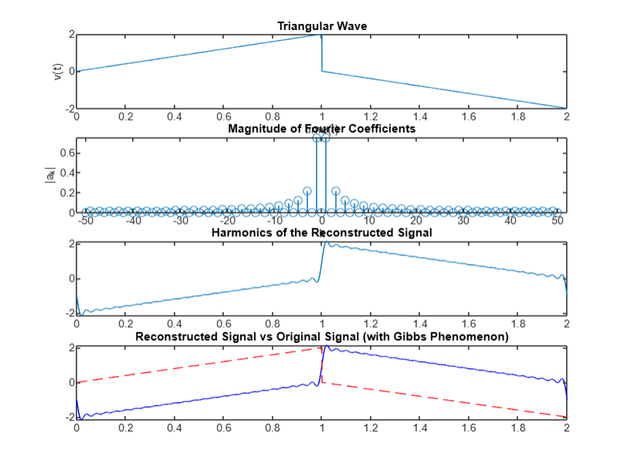

GIBBS PHENOMENON – Signum Function

clc;

clear all;

close all;

% Time period and other variables

time_period = 2; % for signum function representation

step_size_t = 0.0001;

t = -time_period/2:step_size_t:time_period/2; % Symmetric time range around zero

tt = length(t);

omega_o = 2 * pi / time_period; % Fundamental angular frequency

% Number of Fourier coefficients

no_of_fourier_coeff = 50;

kk = -no_of_fourier_coeff:1:no_of_fourier_coeff;

% Initialize v_t for signum function signal

v_t = zeros(1, tt);

for ii = 1:tt

if t(ii) < 0

v_t(ii) = -1; % Negative values

elseif t(ii) == 0

v_t(ii) = 0; % Zero

else

v_t(ii) = 1; % Positive values

end

end

% Plot the signum function

subplot(4,2,[1,2]), plot(t, v_t);

xlabel("time(t)");

ylabel("v(t)");

title('Signum Function');

% Fourier coefficient array initialization

a_k = zeros(1, 2 * no_of_fourier_coeff + 1); % For storing Fourier coefficients

% Calculate Fourier coefficients

for ii = 1:1:(2 * no_of_fourier_coeff + 1)

k = kk(ii); % Fourier series index

temp1 = v_t .* exp(-1i * k * omega_o * t); % v(t) * exp(-j * k * omega_o * t)

% Integrate over the period using trapezoidal rule

int_ans = my_int_func(temp1, step_size_t);

% Calculate Fourier coefficient

a_k(ii) = (1 / time_period) * int_ans;

end

% Plot Fourier coefficients

subplot(4,2,[3,4]), stem(kk, abs(a_k));

xlabel('k');

ylabel('|a_k|');

title('Magnitude of Fourier Coefficients');

% Initialize harmonics

harmonics = zeros(1, tt);

% Reconstruct signal from harmonics

mid_term_of_fs = no_of_fourier_coeff + 1;

for ii = 1:no_of_fourier_coeff % Fixed range for ii

if ii == 1

harmonics = harmonics + a_k(mid_term_of_fs) * exp(1i * 0 * omega_o * t);

else

harmonics = harmonics + a_k(mid_term_of_fs - ii + 1) * exp(1i * (ii-1) * omega_o * t) + ...

a_k(mid_term_of_fs + ii - 1) * exp(-1i * (ii-1) * omega_o * t);

end

end

% Plot the harmonics

subplot(4,2,[5,6]), plot(t, real(harmonics))

title('Harmonics of the Reconstructed Signal');

% Plot the reconstructed signal vs original signal

reconstructed_signal = real(harmonics);

subplot(4,2,[7,8]), plot(t, reconstructed_signal, 'b', t, v_t, '--r');

title('Reconstructed Signal vs Original Signal (with Gibbs Phenomenon)');

\% Custom integration function

function [int_ans] = my_int_func(Data, step_size_t)

int_ans = (step_size_t / 2) * (Data(1) + Data(end) + 2 * sum(Data(2:end-1)));

end

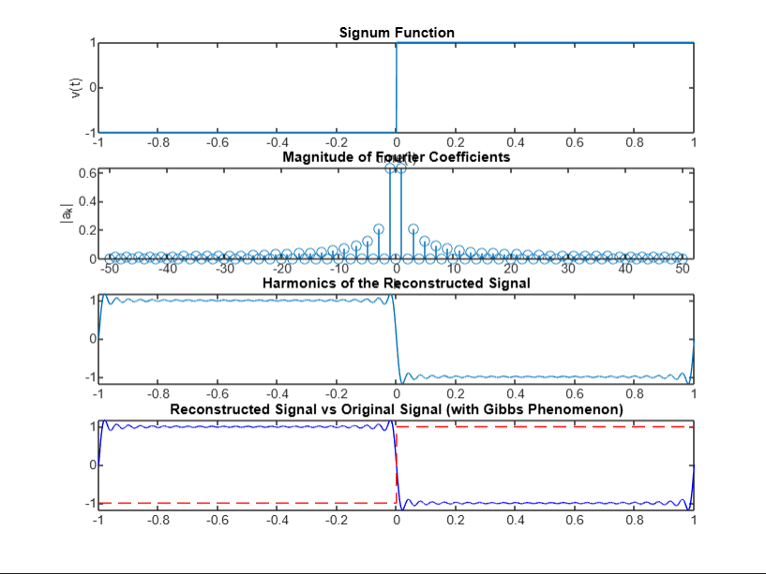

GIBBS PHENOMENON – Unit Step Function

clc;

clear all;

close all;

% Time period and other variables

time_period = 2; % for unit step function representation

step_size_t = 0.0001;

t = -time_period/2:step_size_t:time_period/2; % Symmetric time range around zero

tt = length(t);

omega_o = 2 * pi / time_period; % Fundamental angular frequency

% Number of Fourier coefficients

no_of_fourier_coeff = 50;

kk = -no_of_fourier_coeff:1:no_of_fourier_coeff;

% Initialize v_t for unit step function

v_t = zeros(1, tt);

for ii = 1:tt

if t(ii) < 0

v_t(ii) = 0; % Values before 0

else

v_t(ii) = 1; % Values from 0 onward

end

end

% Plot the unit step function

subplot(4,2,[1,2]), plot(t, v_t);

xlabel("time(t)");

ylabel("v(t)");

title('Unit Step Function');

% Fourier coefficient array initialization

a_k = zeros(1, 2 * no_of_fourier_coeff + 1); % For storing Fourier coefficients

% Calculate Fourier coefficients

for ii = 1:1:(2 * no_of_fourier_coeff + 1)

k = kk(ii); % Fourier series index

temp1 = v_t .* exp(-1i * k * omega_o * t); % v(t) * exp(-j * k * omega_o * t)

% Integrate over the period using trapezoidal rule

int_ans = my_int_func(temp1, step_size_t);

% Calculate Fourier coefficient

a_k(ii) = (1 / time_period) * int_ans;

end

% Plot Fourier coefficients

subplot(4,2,[3,4]), stem(kk, abs(a_k));

xlabel('k');

ylabel('|a_k|');

title('Magnitude of Fourier Coefficients');

% Initialize harmonics

harmonics = zeros(1, tt);

% Reconstruct signal from harmonics

mid_term_of_fs = no_of_fourier_coeff + 1;

for ii = 1:no_of_fourier_coeff

if ii == 1

harmonics = harmonics + a_k(mid_term_of_fs) * exp(1i * 0 * omega_o * t);

else

harmonics = harmonics + a_k(mid_term_of_fs - ii + 1) * exp(1i * (ii-1) * omega_o * t) + ...

a_k(mid_term_of_fs + ii - 1) * exp(-1i * (ii-1) * omega_o * t);

end

end

% Plot the harmonics

subplot(4,2,[5,6]), plot(t, real(harmonics));

title('Harmonics of the Reconstructed Signal');

% Plot the reconstructed signal vs original signal

reconstructed_signal = real(harmonics);

subplot(4,2,[7,8]), plot(t, reconstructed_signal, 'b', t, v_t, '--r');

title('Reconstructed Signal vs Original Signal (with Gibbs Phenomenon)');

% Custom integration function

function [int_ans] = my_int_func(Data, step_size_t)

int_ans = (step_size_t / 2) * (Data(1) + Data(end) + 2 * sum(Data(2:end-1)));

end

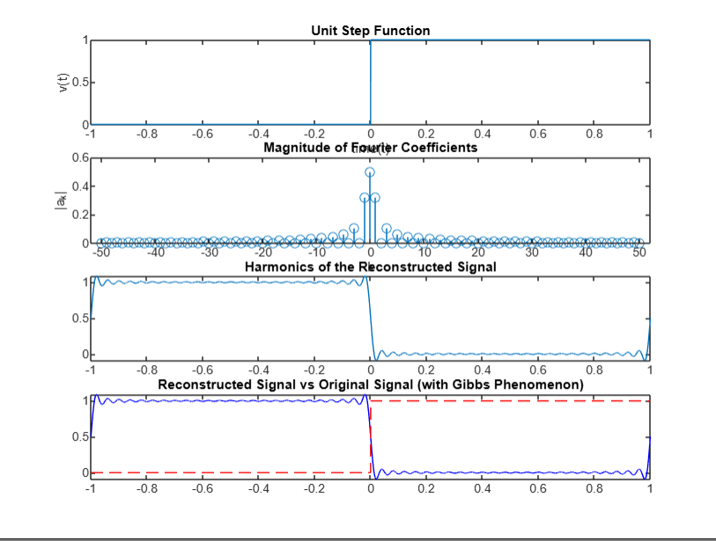

GIBBS PHENOMENON – Rectified Sine Wave

clc;

clear all;

close all;

% Time period and other variables

time_period = 2.*pi; % Time period for rectified sine function representation

step_size_t = 0.0001;

t = -time_period/2:step_size_t:time_period/2; % Symmetric time range around zero

tt = length(t);

omega_o = 2 * pi / time_period; % Fundamental angular frequency

% Number of Fourier coefficients

no_of_fourier_coeff = 50;

kk = -no_of_fourier_coeff:1:no_of_fourier_coeff;

% Initialize v_t for rectified sine function

v_t_sine = zeros(1, tt); % Preallocate v_t_sine with zeros

for ii = 1:tt

if t(ii) >= 0 && t(ii) <= pi

v_t_sine(ii) = sin(t(ii)); % Correct assignment with indexing

else

v_t_sine(ii) = 0; % Assign zero for negative values

end

end

% Plot the rectified sine function

subplot(4,2,[1,2]), plot(t, v_t_sine);

xlabel("time(t)");

ylabel("v(t)");

title('Rectified Sine Function');

% Fourier coefficient array initialization

a_k = zeros(1, 2 * no_of_fourier_coeff + 1); % For storing Fourier coefficients

% Calculate Fourier coefficients

for ii = 1:(2 * no_of_fourier_coeff + 1)

k = kk(ii); % Fourier series index

temp1 = v_t_sine .* exp(-1i * k * omega_o * t); % v(t) * exp(-j * k * omega_o * t)

% Integrate over the period using trapezoidal rule

int_ans = my_int_func(temp1, step_size_t);

% Calculate Fourier coefficient

a_k(ii) = (1 / time_period) * int_ans;

end

% Plot Fourier coefficients

subplot(4,2,[3,4]), stem(kk, abs(a_k));

xlabel('k');

ylabel('|a_k|');

title('Magnitude of Fourier Coefficients');

% Initialize harmonics

harmonics = zeros(1, tt);

% Reconstruct signal from harmonics

mid_term_of_fs = no_of_fourier_coeff + 1;

for ii = 1:no_of_fourier_coeff

if ii == 1

harmonics = harmonics + a_k(mid_term_of_fs) * exp(1i * 0 * omega_o * t);

else

harmonics = harmonics + a_k(mid_term_of_fs - ii + 1) * exp(1i * (ii-1) * omega_o * t) + ...

a_k(mid_term_of_fs + ii - 1) * exp(-1i * (ii-1) * omega_o * t);

end

end

% Plot the harmonics

subplot(4,2,[5,6]), plot(t, real(harmonics));

title('Harmonics of the Reconstructed Signal');

% Plot the reconstructed signal vs original signal

reconstructed_signal = real(harmonics);

subplot(4,2,[7,8]), plot(t, reconstructed_signal, 'b', t, v_t_sine, '--r');

xlabel('time(t)');

ylabel('Signal Amplitude');

title('Reconstructed Signal vs Original Rectified Sine Signal (with Gibbs Phenomenon)');

% Custom integration function

function [int_ans] = my_int_func(Data, step_size_t)

int_ans = (step_size_t / 2) * (Data(1) + Data(end) + 2 * sum(Data(2:end-1)));

end

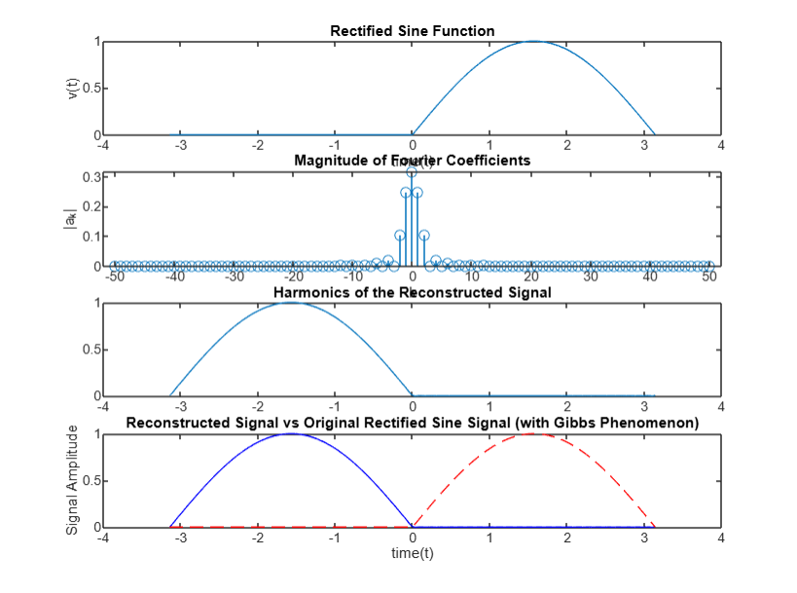

GIBBS PHENOMENON – Rectified Cosine Wave

clc;

clear all;

close all;

% Time period and other variables

time_period = 2.*pi; % Time period for rectified cosine function representation

step_size_t = 0.0001;

t = -time_period/2:step_size_t:time_period/2; % Symmetric time range around zero

tt = length(t);

omega_o = 2 * pi / time_period; % Fundamental angular frequency

% Number of Fourier coefficients

no_of_fourier_coeff = 50;

kk = -no_of_fourier_coeff:1:no_of_fourier_coeff;

% Initialize v_t for rectified cosine function

v_t_cosine = zeros(1, tt); % Preallocate v_t_cosine with zeros

for ii = 1:tt

if t(ii) >= -pi/2 && t(ii) <= pi/2

v_t_cosine(ii) = cos(t(ii)); % Rectified cosine function

else

v_t_cosine(ii) = 0; % Assign zero for negative values

end

end

% Plot the rectified cosine function

subplot(4,2,[1,2]), plot(t, v_t_cosine);

xlabel("time(t)");

ylabel("v(t)");

title('Rectified Cosine Function');

% Fourier coefficient array initialization

a_k = zeros(1, 2 * no_of_fourier_coeff + 1); % For storing Fourier coefficients

% Calculate Fourier coefficients

for ii = 1:(2 * no_of_fourier_coeff + 1)

k = kk(ii); % Fourier series index

temp1 = v_t_cosine .* exp(-1i * k * omega_o * t); % v(t) * exp(-j * k * omega_o * t)

% Integrate over the period using trapezoidal rule

int_ans = my_int_func(temp1, step_size_t);

% Calculate Fourier coefficient

a_k(ii) = (1 / time_period) * int_ans;

end

% Plot Fourier coefficients

subplot(4,2,[3,4]), stem(kk, abs(a_k));

xlabel('k');

ylabel('|a_k|');

title('Magnitude of Fourier Coefficients');

% Initialize harmonics

harmonics = zeros(1, tt);

% Reconstruct signal from harmonics

mid_term_of_fs = no_of_fourier_coeff + 1;

for ii = 1:no_of_fourier_coeff

if ii == 1

harmonics = harmonics + a_k(mid_term_of_fs) * exp(1i * 0 * omega_o * t);

else

harmonics = harmonics + a_k(mid_term_of_fs - ii + 1) * exp(1i * (ii-1) * omega_o * t) + ...

a_k(mid_term_of_fs + ii - 1) * exp(-1i * (ii-1) * omega_o * t);

end

end

% Plot the harmonics

subplot(4,2,[5,6]), plot(t, real(harmonics));

title('Harmonics of the Reconstructed Signal');

% Plot the reconstructed signal vs original signal

reconstructed_signal = real(harmonics);

subplot(4,2,[7,8]), plot(t, reconstructed_signal, 'b', t, v_t_cosine, '--r');

xlabel('time(t)');

ylabel('Signal Amplitude');

title('Reconstructed Signal vs Original Rectified Cosine Signal (with Gibbs Phenomenon)');

% Custom integration function

function [int_ans] = my_int_func(Data, step_size_t)

int_ans = (step_size_t / 2) * (Data(1) + Data(end) + 2 * sum(Data(2:end-1)));

end

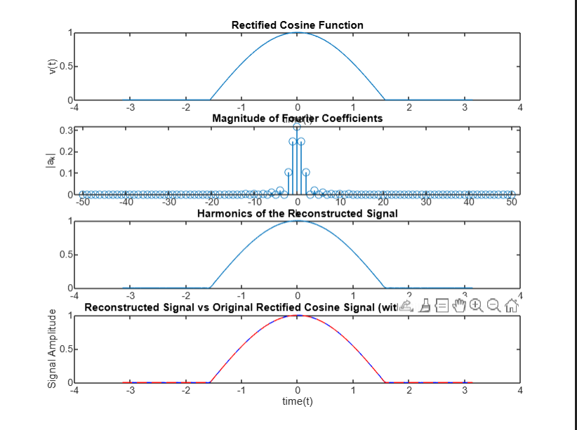

FOURIER TRANSFORMS – Sinc Function

clear all;

close all;

clc

% Constants

step_omega= 0.01 * pi;

step_size_t = 0.1;

t = -10:step_size_t:10;

length_t = length(t);

% Omega range for frequency domain

omegax = -(1 / step_size_t) * pi : step_omega : (1 / step_size_t) * pi;

length_omega = length(omegax);

% Pre-allocate arrays

expo_omega = zeros(length_omega, length_t);

x_omega = zeros(1, length_omega);

x_t_reconstructed = zeros(1, length_t);

% Create Fourier exponentials

for ii = 1:length_omega

expo_omega(ii, :) = exp(-1j * omegax(ii) * t);

end

% Pre-allocate array for sinc function

x_t = zeros(1, length_t);

% Define sinc function in time domain

for ii = 1:length_t

if t(ii) == 0

x_t(ii) = 1; % Define sinc(0) = 1

else

% Corrected sinc function formula (as per original structure)

x_t(ii) = sin((2 * pi * (1/(2 * step_size_t))) * 0.5 * t(ii)) / ...

((2 * pi * (1/(2 * step_size_t))) * 0.5 * t(ii));

end

end

% Plot the sinc function

subplot(4,1,1), plot(t, x_t);

xlabel('time (t)');

ylabel('x(t)');

title('Sinc Function in Time Domain');

% Compute Fourier Transform X(ω)

for ii = 1:length_omega

temp = x_t .* expo_omega(ii, :); % x(t) * exp(-jωt)

x_omega(ii) = my_int_func(temp, step_size_t); % Fourier Transform

end

% Plot the magnitude of the Fourier transform

subplot(4,1,2), plot(omegax ./ pi, abs(x_omega));

xlabel('\omega/\pi');

ylabel('|X(\omega)|');

title('Fourier Transform of the Sinc Function');

% Inverse Fourier Transform (reconstruct x(t))

expo_omega_2 = exp(1j * omegax' * t); % Create matrix of exp(jωt) for inverse transform

for ii = 1:length_t

temp_2 = x_omega .* expo_omega_2(:, ii).'; % X(ω) * exp(jωt)

x_t_reconstructed(ii) = (1 / (2 * pi)) * my_int_func(temp_2, step_omega); % Inverse Fourier Transform

end

% Plot the reconstructed signal

subplot(4,1,3), plot(t, real(x_t_reconstructed));

xlabel('time (t)');

ylabel('Reconstructed x(t)');

title('Reconstructed Signal from Fourier Transform');

% Calculate and plot the phase of X(omega)

Angle_X_Omega = atan2(imag(x_omega), real(x_omega)); % Compute phase using atan2 for correct quadrant

% Plot the phase of the Fourier transform

subplot(4,1,4), plot(omegax ./ pi, Angle_X_Omega);

xlabel('\omega/\pi');

ylabel('Phase \angle X(\omega) (radians)');

title('Phase of Fourier Transform X(\omega)');

%Custom integration function (trapezoidal rule)

function [int_ans] = my_int_func(Data, step_size)

int_ans = (step_size / 2) * (Data(1) + Data(end) + 2 * sum(Data(2:end-1)));

end

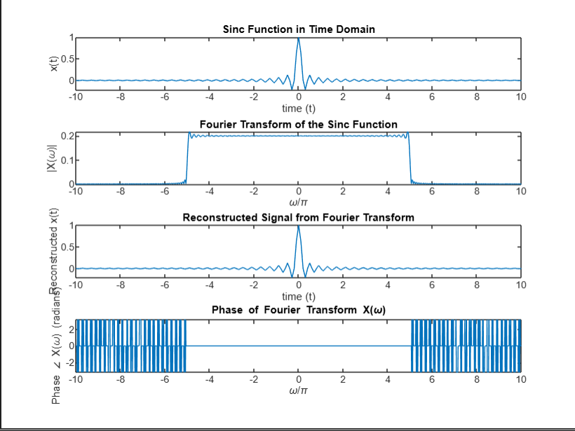

FOURIER TRANSFORMS – Exponential Decay Function

clear all;

close all;

clc

% Constants

step_omega = 0.01 * pi;

step_size_t = 0.1;

t = -10:step_size_t:10;

length_t = length(t);

% Omega range for frequency domain

omegax = -(1 / step_size_t) * pi : step_omega : (1 / step_size_t) * pi;

length_omega = length(omegax);

% Pre-allocate arrays

expo_omega = zeros(length_omega, length_t);

x_omega = zeros(1, length_omega);

x_t_reconstructed = zeros(1, length_t);

% Create Fourier exponentials

for ii = 1:length_omega

expo_omega(ii, :) = exp(-1j * omegax(ii) * t);

end

% Define exponential decay function

for ii = 1:length_t

if t(ii) < 0

x_t(ii) = 0; % Set to 0 for t < 0

else

x_t(ii) = 3 * exp(-2 * t(ii)); % Exponential decay for t >= 0

end

end

% Plot the exponential decay function

subplot(4,1,1), plot(t, x_t);

xlabel('time (t)');

ylabel('x(t)');

title('Exponential Decay Function in Time Domain');

% Compute Fourier Transform X(ω)

for ii = 1:length_omega

temp = x_t .* expo_omega(ii, :); % x(t) * exp(-jωt)

x_omega(ii) = my_int_func(temp, step_size_t); % Fourier Transform

end

% Plot the magnitude of the Fourier transform

subplot(4,1,2), plot(omegax ./ pi, abs(x_omega));

xlabel('\omega/\pi');

ylabel('|X(\omega)|');

title('Fourier Transform of the Exponential Decay Function');

% Inverse Fourier Transform (reconstruct x(t))

expo_omega_2 = exp(1j * omegax' * t); % Create matrix of exp(jωt) for inverse transform

for ii = 1:length_t

temp_2 = x_omega .* expo_omega_2(:, ii).'; % X(ω) * exp(jωt)

x_t_reconstructed(ii) = (1 / (2 * pi)) * my_int_func(temp_2, step_omega); % Inverse Fourier Transform

end

% Plot the reconstructed signal

subplot(4,1,3), plot(t, real(x_t_reconstructed));

xlabel('time (t)');

ylabel('Reconstructed x(t)');

title('Reconstructed Signal from Fourier Transform');

% Calculate and plot the phase of X(omega)

Angle_X_Omega = atan2(imag(x_omega), real(x_omega)); % Compute phase using atan2 for correct quadrant

% Plot the phase of the Fourier transform

subplot(4,1,4), plot(omegax ./ pi, Angle_X_Omega);

xlabel('\omega/\pi');

ylabel('Phase \angle X(\omega) (radians)');

title('Phase of Fourier Transform X(\omega)');

% Custom integration function (trapezoidal rule)

function [int_ans] = my_int_func(Data, step_size)

int_ans = (step_size / 2) * (Data(1) + Data(end) + 2 * sum(Data(2:end-1)));

end

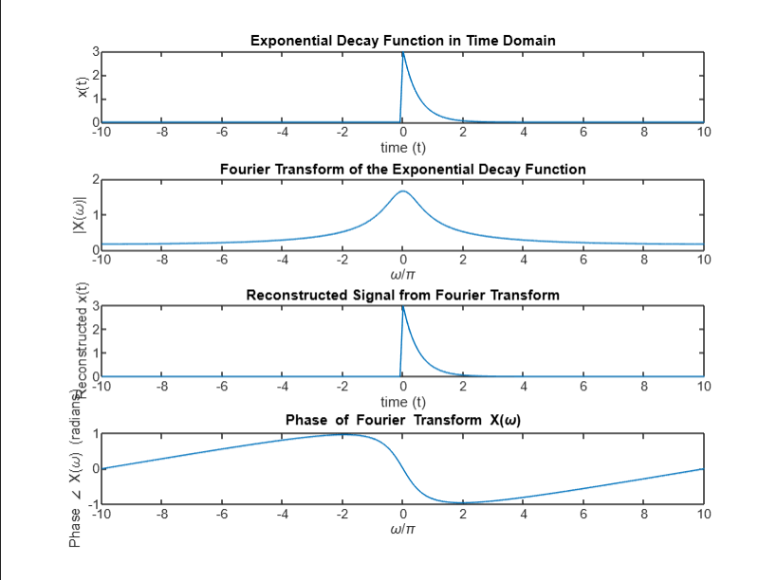

FOURIER TRANSFORMS – Double-Sided Exponential Decay Function

clear all;

close all;

clc

% Constants

step_omega = 0.01 * pi;

step_size_t = 0.1;

t = -10:step_size_t:10;

length_t = length(t);

% Omega range for frequency domain

omegax = -(1 / step_size_t) * pi : step_omega : (1 / step_size_t) * pi;

length_omega = length(omegax);

% Pre-allocate arrays

expo_omega = zeros(length_omega, length_t);

x_omega = zeros(1, length_omega);

x_t_reconstructed = zeros(1, length_t);

% Create Fourier exponentials

for ii = 1:length_omega

expo_omega(ii, :) = exp(-1j * omegax(ii) * t);

end

% Define double-sided exponential function

x_t = zeros(1, length_t); % Initialize x_t with zeros

% Define exponential growth for t < 0 and decay for t >= 0

for ii = 1:length_t

if t(ii) < 0

x_t(ii) = 3 * exp(2 * t(ii)); % Exponential growth for t < 0

else

x_t(ii) = 3 * exp(-2 * t(ii)); % Exponential decay for t >= 0

end

end

% Plot the double-sided exponential function

subplot(4,1,1), plot(t, x_t);

xlabel('time (t)');

ylabel('x(t)');

title('Double-Sided Exponential Function in Time Domain');

% Compute Fourier Transform X(ω)

for ii = 1:length_omega

temp = x_t .* expo_omega(ii, :); % x(t) * exp(-jωt)

x_omega(ii) = my_int_func(temp, step_size_t); % Fourier Transform

end

% Plot the magnitude of the Fourier transform

subplot(4,1,2), plot(omegax ./ pi, abs(x_omega));

xlabel('\omega/\pi');

ylabel('|X(\omega)|');

title('Fourier Transform of the Double-Sided Exponential Function');

% Inverse Fourier Transform (reconstruct x(t))

expo_omega_2 = exp(1j * omegax' * t); % Create matrix of exp(jωt) for inverse transform

for ii = 1:length_t

temp_2 = x_omega .* expo_omega_2(:, ii).'; % X(ω) * exp(jωt)

x_t_reconstructed(ii) = (1 / (2 * pi)) * my_int_func(temp_2, step_omega); % Inverse Fourier Transform

end

% Plot the reconstructed signal

subplot(4,1,3), plot(t, real(x_t_reconstructed));

xlabel('time (t)');

ylabel('Reconstructed x(t)');

title('Reconstructed Signal from Fourier Transform');

% Calculate and plot the phase of X(omega)

Angle_X_Omega = atan2(imag(x_omega), real(x_omega)); % Compute phase using atan2 for correct quadrant

% Plot the phase of the Fourier transform

subplot(4,1,4), plot(omegax ./ pi, Angle_X_Omega);

xlabel('\omega/\pi');

ylabel('Phase \angle X(\omega) (radians)');

title('Phase of Fourier Transform X(\omega)');

% Custom integration function (trapezoidal rule)

function [int_ans] = my_int_func(Data, step_size)

int_ans = (step_size / 2) * (Data(1) + Data(end) + 2 * sum(Data(2:end-1)));

end

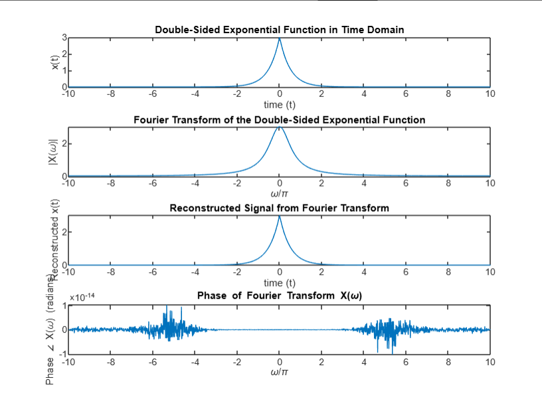

FOURIER TRANSFORMS – Sine Function

clear all;

close all;

clc

% Constants

step_omega = 0.01 * pi;

step_size_t = 0.1;

t = -10:step_size_t:10;

length_t = length(t);

% Omega range for frequency domain

omegax = -(1 / step_size_t) * pi : step_omega : (1 / step_size_t) * pi;

length_omega = length(omegax);

% Pre-allocate arrays

expo_omega = zeros(length_omega, length_t);

x_omega = zeros(1, length_omega);

x_t_reconstructed = zeros(1, length_t);

% Create Fourier exponentials

for ii = 1:length_omega

expo_omega(ii, :) = exp(-1j * omegax(ii) * t);

end

% Define sine function within a specified range

x_t = zeros(1, length_t); % Initialize x_t with zeros

for ii = 1:length_t

x_t(ii) = sin(t(ii));

end

% Plot the sine function in the time domain

subplot(4,1,1), plot(t, x_t);

xlabel('time (t)');

ylabel('x(t)');

title('Sine Function in Time Domain');

% Compute Fourier Transform X(ω)

for ii = 1:length_omega

temp = x_t .* expo_omega(ii, :); % x(t) * exp(-jωt)

x_omega(ii) = my_int_func(temp, step_size_t); % Fourier Transform

end

% Plot the magnitude of the Fourier transform

subplot(4,1,2), plot(omegax ./ pi, abs(x_omega));

xlabel('\omega/\pi');

ylabel('|X(\omega)|');

title('Fourier Transform of the Sine Function');

% Inverse Fourier Transform (reconstruct x(t))

expo_omega_2 = exp(1j * omegax' * t); % Create matrix of exp(jωt) for inverse transform

for ii = 1:length_t

temp_2 = x_omega .* expo_omega_2(:, ii).'; % X(ω) * exp(jωt)

x_t_reconstructed(ii) = (1 / (2 * pi)) * my_int_func(temp_2, step_omega); % Inverse Fourier Transform

end

% Plot the reconstructed signal

subplot(4,1,3), plot(t, real(x_t_reconstructed));

xlabel('time (t)');

ylabel('Reconstructed x(t)');

title('Reconstructed Signal from Fourier Transform');

% Calculate and plot the phase of X(omega)

Angle_X_Omega = atan2(imag(x_omega), real(x_omega)); % Compute phase using atan2 for correct quadrant

% Plot the phase of the Fourier transform

subplot(4,1,4), plot(omegax ./ pi, Angle_X_Omega);

xlabel('\omega/\pi');

ylabel('Phase \angle X(\omega) (radians)');

title('Phase of Fourier Transform X(\omega)');

% Custom integration function (trapezoidal rule)

function [int_ans] = my_int_func(Data, step_size)

int_ans = (step_size / 2) * (Data(1) + Data(end) + 2 * sum(Data(2:end-1)));

end

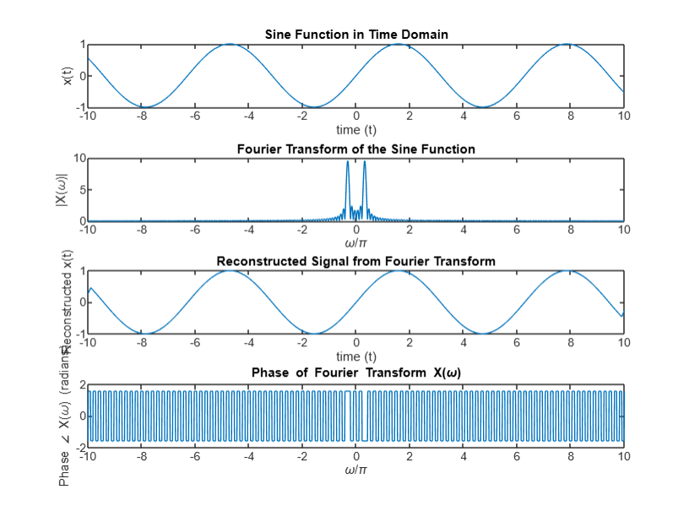

FOURIER TRANSFORMS – Cosine Function

clear all;

close all;

clc

% Constants

step_omega = 0.01 * pi;

step_size_t = 0.1;

t = -10:step_size_t:10; % Time vector

length_t = length(t); % Length of time vector

% Omega range for frequency domain

omegax = -(1 / step_size_t) * pi : step_omega : (1 / step_size_t) * pi;

length_omega = length(omegax);

% Pre-allocate arrays

expo_omega = zeros(length_omega, length_t);

x_omega = zeros(1, length_omega);

x_t_reconstructed = zeros(1, length_t);

% Create Fourier exponentials

for ii = 1:length_omega

expo_omega(ii, :) = exp(-1j * omegax(ii) * t); % Exponential matrix for Fourier Transform

end

% Define cosine function

x_t = zeros(1, length_t); % Initialize x_t with zeros

for ii = 1:length_t

x_t(ii) = cos(t(ii)); % Cosine function

end

% Plot the cosine function in the time domain

subplot(4,1,1), plot(t, x_t);

xlabel('time (t)');

ylabel('x(t)');

title('Cosine Function in Time Domain'); % Updated title for cosine function

% Compute Fourier Transform X(ω)

for ii = 1:length_omega

temp = x_t .* expo_omega(ii, :); % x(t) * exp(-jωt)

x_omega(ii) = my_int_func(temp, step_size_t); % Fourier Transform

end

% Plot the magnitude of the Fourier transform

subplot(4,1,2), plot(omegax ./ pi, abs(x_omega));

xlabel('\omega/\pi');

ylabel('|X(\omega)|');

title('Fourier Transform of the Cosine Function'); % Updated title for cosine function

% Inverse Fourier Transform (reconstruct x(t))

expo_omega_2 = exp(1j * omegax' * t); % Create matrix of exp(jωt) for inverse transform

for ii = 1:length_t

temp_2 = x_omega .* expo_omega_2(:, ii).'; % X(ω) * exp(jωt)

x_t_reconstructed(ii) = (1 / (2 * pi)) * my_int_func(temp_2, step_omega); % Inverse Fourier Transform

end

% Plot the reconstructed signal

subplot(4,1,3), plot(t, real(x_t_reconstructed));

xlabel('time (t)');

ylabel('Reconstructed x(t)');

title('Reconstructed Signal from Fourier Transform'); % Title for reconstructed signal

% Calculate and plot the phase of X(ω)

Angle_X_Omega = atan2(imag(x_omega), real(x_omega)); % Compute phase using atan2 for correct quadrant

% Plot the phase of the Fourier transform

subplot(4,1,4), plot(omegax ./ pi, Angle_X_Omega);

xlabel('\omega/\pi');

ylabel('Phase \angle X(\omega) (radians)');

title('Phase of Fourier Transform X(\omega)'); % Title for phase plot

% Custom integration function (trapezoidal rule)

function [int_ans] = my_int_func(Data, step_size)

int_ans = (step_size / 2) * (Data(1) + Data(end) + 2 * sum(Data(2:end-1))); % Trapezoidal rule

end

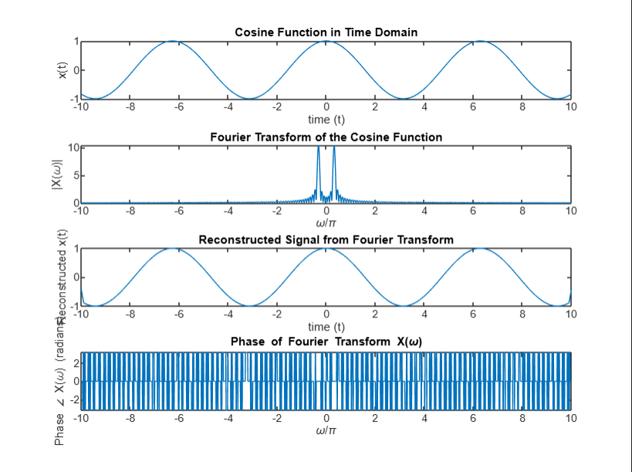

FOURIER TRANSFORMS – Unit Step Function

clear all;

close all;

clc;

% Constants

step_omega = 0.01 * pi;

step_size_t = 0.1;

t = -10:step_size_t:10; % Time vector

length_t = length(t); % Length of time vector

% Omega range for frequency domain

omegax = -(1 / step_size_t) * pi : step_omega : (1 / step_size_t) * pi;

length_omega = length(omegax);

% Pre-allocate arrays

expo_omega = zeros(length_omega, length_t);

x_omega = zeros(1, length_omega);

x_t_reconstructed = zeros(1, length_t);

x_t = zeros(1, length_t); % Initialize x(t)

% Create Fourier exponentials

for ii = 1:length_omega

expo_omega(ii, :) = exp(-1j * omegax(ii) * t); % Exponential matrix for Fourier Transform

end

% Define Unit Step Function

for ii = 1:length_t % Use length_t instead of undefined tt

if t(ii) < 0

x_t(ii) = 0; % Values before 0

else

x_t(ii) = 1; % Values from 0 onward

end

end

% Plot the unit step function in the time domain

subplot(4,1,1), plot(t, x_t);

xlabel('time (t)');

ylabel('x(t)');

title('Unit Step Function in Time Domain'); % Updated title for unit step function

% Compute Fourier Transform X(ω)

for ii = 1:length_omega

temp = x_t .* expo_omega(ii, :); % x(t) * exp(-jωt)

x_omega(ii) = my_int_func(temp, step_size_t); % Fourier Transform

end

% Plot the magnitude of the Fourier transform

subplot(4,1,2), plot(omegax ./ pi, abs(x_omega));

xlabel('\omega/\pi');

ylabel('|X(\omega)|');

title('Magnitude of Fourier Transform of Unit Step Function'); % Updated title

% Inverse Fourier Transform (reconstruct x(t))

expo_omega_2 = exp(1j * omegax' * t); % Create matrix of exp(jωt) for inverse transform

for ii = 1:length_t

temp_2 = x_omega .* expo_omega_2(:, ii).'; % X(ω) * exp(jωt)

x_t_reconstructed(ii) = (1 / (2 * pi)) * my_int_func(temp_2, step_omega); % Inverse Fourier Transform

end

% Plot the reconstructed signal

subplot(4,1,3), plot(t, real(x_t_reconstructed));

xlabel('time (t)');

ylabel('Reconstructed x(t)');

title('Reconstructed Signal from Fourier Transform'); % Title for reconstructed signal

% Calculate and plot the phase of X(ω)

Angle_X_Omega = atan2(imag(x_omega), real(x_omega)); % Compute phase using atan2 for correct quadrant

% Plot the phase of the Fourier transform

subplot(4,1,4), plot(omegax ./ pi, Angle_X_Omega);

xlabel('\omega/\pi');

ylabel('Phase \angle X(\omega) (radians)');

title('Phase of Fourier Transform X(\omega)'); % Title for phase plot

% Custom integration function (trapezoidal rule)

function [int_ans] = my_int_func(Data, step_size)

int_ans = (step_size / 2) * (Data(1) + Data(end) + 2 * sum(Data(2:end-1))); % Trapezoidal rule

end

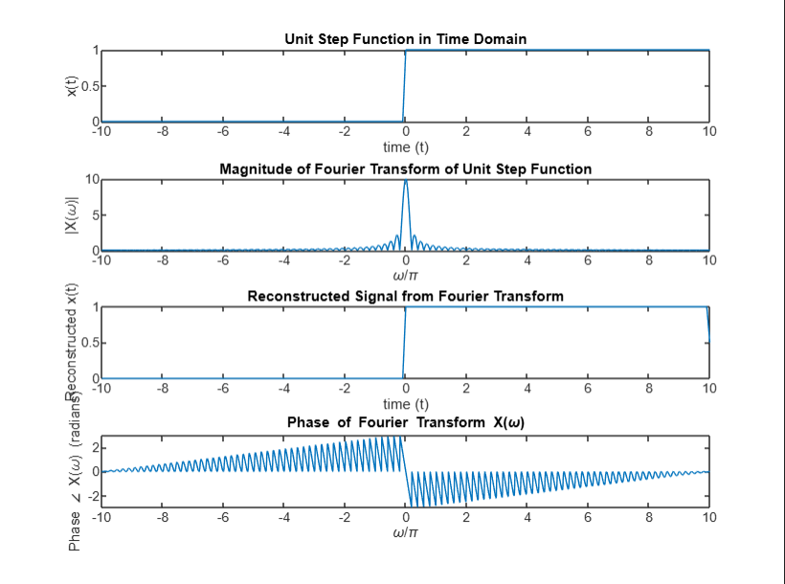

FOURIER TRANSFORMS – Signum Function

clear all;

close all;

clc;

% Constants

step_omega = 0.01 * pi;

step_size_t = 0.1;

t = -10:step_size_t:10; % Time vector

length_t = length(t); % Length of time vector

% Omega range for frequency domain

omegax = -(1 / step_size_t) * pi : step_omega : (1 / step_size_t) * pi;

length_omega = length(omegax);

% Pre-allocate arrays

x_omega = zeros(1, length_omega);

x_t_reconstructed = zeros(1, length_t);

v_t = zeros(1, length_t); % Initialize signum function

% Initialize v_t for signum function signal

for ii = 1:length_t % Use length_t instead of undefined tt

if t(ii) < 0

v_t(ii) = -1; % Negative values

elseif t(ii) == 0

v_t(ii) = 0; % Zero

else

v_t(ii) = 1; % Positive values

end

end

% Plot the signum function in the time domain

subplot(4,1,1), plot(t, v_t);

xlabel('time (t)');

ylabel('v(t)');

title('Signum Function in Time Domain'); % Updated title for signum function

% Compute Fourier Transform X(ω)

for ii = 1:length_omega

temp = v_t .* exp(-1j * omegax(ii) * t); % v(t) * exp(-jωt)

x_omega(ii) = my_int_func(temp, step_size_t); % Fourier Transform

end

% Plot the magnitude of the Fourier transform

subplot(4,1,2), plot(omegax ./ pi, abs(x_omega));

xlabel('\omega/\pi');

ylabel('|X(\omega)|');

title('Magnitude of Fourier Transform of Signum Function'); % Updated title

% Inverse Fourier Transform (reconstruct v(t))

expo_omega_2 = exp(1j * omegax' * t); % Create matrix of exp(jωt) for inverse transform

for ii = 1:length_t

temp_2 = x_omega .* expo_omega_2(:, ii).'; % X(ω) * exp(jωt)

x_t_reconstructed(ii) = (1 / (2 * pi)) * my_int_func(temp_2, step_omega); % Inverse Fourier Transform

end

% Plot the reconstructed signal

subplot(4,1,3), plot(t, real(x_t_reconstructed));

xlabel('time (t)');

ylabel('Reconstructed v(t)');

title('Reconstructed Signal from Fourier Transform'); % Title for reconstructed signal

% Calculate and plot the phase of X(ω)

Angle_X_Omega = atan2(imag(x_omega), real(x_omega)); % Compute phase using atan2 for correct quadrant

% Plot the phase of the Fourier transform

subplot(4,1,4), plot(omegax ./ pi, Angle_X_Omega);

xlabel('\omega/\pi');

ylabel('Phase \angle X(\omega) (radians)');

title('Phase of Fourier Transform X(\omega)'); % Title for phase plot

% Custom integration function (trapezoidal rule)

function [int_ans] = my_int_func(Data, step_size)

int_ans = (step_size / 2) * (Data(1) + Data(end) + 2 * sum(Data(2:end-1))); % Trapezoidal rule

end

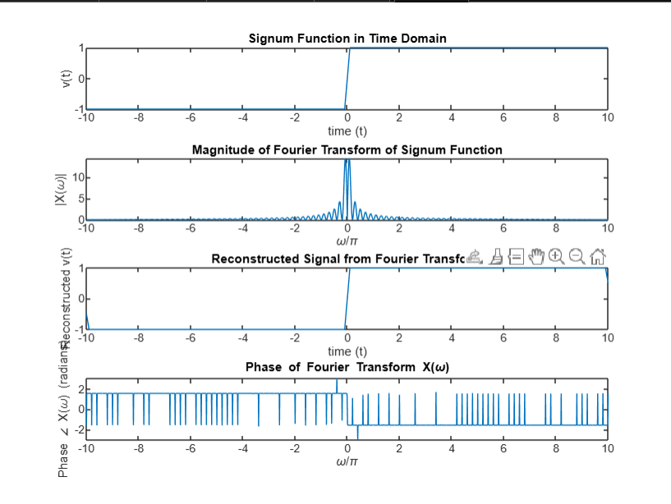

FOURIER TRANSFORMS – Gate Function / Square Wave

clear all;

close all;

clc;

% Constants

step_omega = 0.01 * pi;

step_size_t = 0.1;

t = -5:step_size_t:5; % Time vector

length_t = length(t);

% Omega range for frequency domain

omegax = -(1 / step_size_t) * pi : step_omega : (1 / step_size_t) * pi;

length_omega = length(omegax);

% Pre-allocate arrays

expo_omega = zeros(length_omega, length_t);

x_omega = zeros(1, length_omega);

x_t_reconstructed = zeros(1, length_t);

% Create Fourier exponentials

for ii = 1:length_omega

expo_omega(ii, :) = exp(-1j * omegax(ii) * t);

end

% Define parameters for the square wave (gate function)

period = 5; % Duration of one full period

half_period = period / 2; % Half of the period

% Pre-allocate array for the square wave function

x_t = zeros(1, length_t);

% Create the square wave signal

for ii = 1:length_t

mod_time = mod(t(ii), period); % Determine position within the current period

if (mod_time <= half_period) % High part of the square wave

x_t(ii) = 1; % Set value to 1

else % Low part of the square wave

x_t(ii) = -1; % Set value to -1

end

end

% Plot the square wave function

subplot(4, 1, 1), plot(t, x_t);

xlabel('time (t)');

ylabel('x(t)');

title('Square Wave Function in Time Domain');

% Compute Fourier Transform X(ω)

for ii = 1:length_omega

temp = x_t .* expo_omega(ii, :); % x(t) * exp(-jωt)

x_omega(ii) = my_int_func(temp, step_size_t); % Fourier Transform

end

% Plot the magnitude of the Fourier transform

subplot(4, 1, 2), plot(omegax ./ pi, abs(x_omega));

xlabel('\omega/\pi');

ylabel('|X(\omega)|');

title('Fourier Transform of the Square Wave Function');

% Inverse Fourier Transform (reconstruct x(t))

expo_omega_2 = exp(1j * omegax' * t); % Create matrix of exp(jωt) for inverse transform

for ii = 1:length_t

temp_2 = x_omega .* expo_omega_2(:, ii).'; % X(ω) * exp(jωt)

x_t_reconstructed(ii) = (1 / (2 * pi)) * my_int_func(temp_2, step_omega); % Inverse Fourier Transform

end

% Plot the reconstructed signal

subplot(4, 1, 3), plot(t, real(x_t_reconstructed));

xlabel('time (t)');

ylabel('Reconstructed x(t)');

title('Reconstructed Signal from Fourier Transform');

% Calculate and plot the phase of X(ω)

Angle_X_Omega = atan2(imag(x_omega), real(x_omega)); % Compute phase using atan2 for correct quadrant

% Plot the phase of the Fourier transform

subplot(4, 1, 4), plot(omegax ./ pi, Angle_X_Omega);

xlabel('\omega/\pi');

ylabel('Phase \angle X(\omega) (radians)');

title('Phase of Fourier Transform X(\omega)');

% Custom integration function (trapezoidal rule)

function [int_ans] = my_int_func(Data, step_size)

int_ans = (step_size / 2) * (Data(1) + Data(end) + 2 * sum(Data(2:end-1)));

end

